**Lab 13 – Full Wave Rectifier and Biased Transistor**

***Exercise 1***

***Using PSPICE design a full wave rectifier***

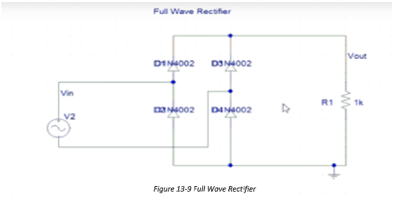

***Circuit in PSpice***

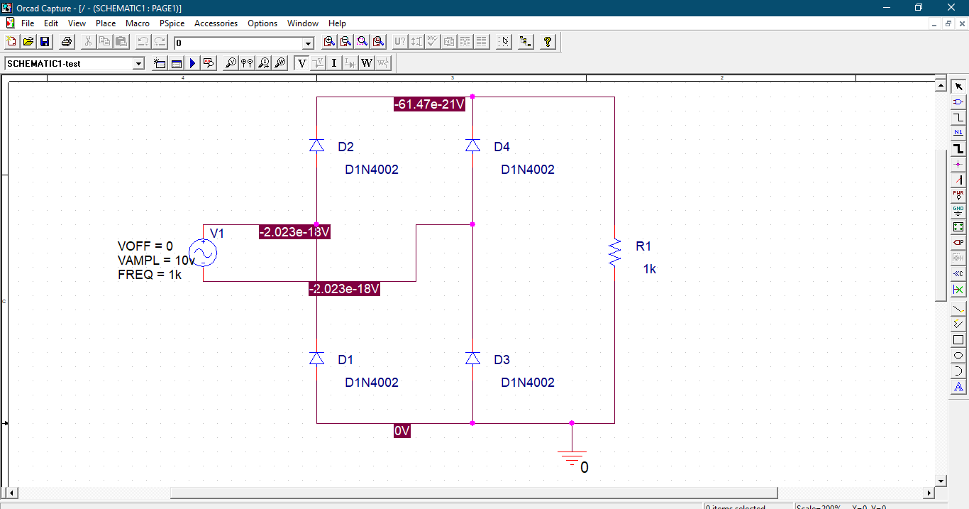

**Output:**

